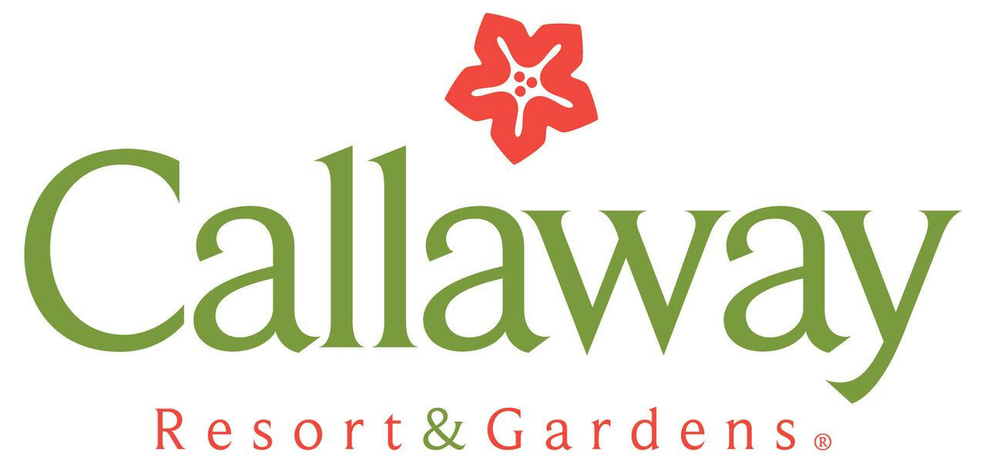
Job Title | Assistant Restaurant Manager for Piedmont/Casons
Department | Food and Beverage
FLSA Classification | Exempt
Date | November 2022
I. Job Summary
Connecting man and nature in a way that benefits both. Callaway Gardens is not just a fun place to visit, it's a fun place to work!
We are looking for an Assistant Restaurant Manager to assist Restaurant Manager lead all aspects of our business. You will deliver a high-quality menu and motivate our staff to provide excellent customer service. Assistant Restaurant manager responsibilities include maintaining the restaurant's revenue, profitability, and quality goals. You will ensure efficient restaurant operation, as well as maintain high production, productivity, quality, and customer-service standards. To be successful in this role, you'll need management skills and experience in both front and back of the house. We want you to know how to oversee the dining room, check-in with customers and balance seating capacity and make sure we comply with health and safety restaurant regulations. We'll expect you to lead by example and uplift our staff during busy moments in our fast-paced environment. Ultimately, you will ensure our restaurant runs smoothly and customers have pleasant dining experiences.

ll. Qualifications
- Proven work experience as a Assistant Restaurant Manager, or similar role
- Proven guest service experience as a manager
- Familiarity with restaurant management software and POS systems
- Strong leadership, motivational and people skills
- Acute financial management skills
III. Behavioral Requirements and Physical Requirements
- Able to project Employer's wholesome image by being genuinely friendly and caring and by taking pride in their work.
- Must put SAFETY first while ensuring guest receives a memorable experience
- Must be self-motivated and disciplined.
- Must be able to prioritize and complete work assignments on a timely basis.
- Must maintain strict confidentiality and judgment regarding privileged information.
- Must be willing to constantly improve.
- Must have professional appearance with good personal hygiene.
- Must promote and support a "team" work environment by cooperating, helping co-workers and working across various departments.
- Must adapt to changes easily.
- Must enjoy a fast-paced, dynamic environment.
- Must show appreciation to others.
- Must be sensitive to the needs of our Guests and feel empowered to take action to meet their needs within company guidelines.
- Self-supervised and disciplined to prioritize and complete workload on a timely basis.
- Identifies and resolves problems in a timely manner; develops alternative solutions; works well in group problem solving situations.
- Exhibits objectivity and openness to other's views; gives and welcomes feedback; puts success of teams above own interests; inspires trust of others.
Physical Requirements
- Ability to stand and walk for extended periods of time
- Ability to lift 25 pounds

IV. Duties and Functions
- Coordinate daily Front of the House restaurant operations
- Deliver superior service and maximize guest satisfaction
- Respond efficiently and accurately to guest complaints
- Regularly review product quality
- Organize and supervise shifts
- Appraise staff performance and provide feedback to improve productivity
- Ensure compliance with sanitation and safety regulations
- Manage restaurant's good image and suggest ways to improve it
- Control operational costs and identify measures to cut waste
- Promote the brand in the local community through word-of-mouth and restaurant events
- Recommend ways to reach a broader audience (e.g. discounts and social media ads)
- Train new and current employees on proper guest service practices
- Implement policies and protocols that will maintain future restaurant operations
Management reserves the right to change and/or add to these duties at any time.

Callaway Resort & Gardens provides equal access to and opportunity in its employment without regard to race, color, creed, religion, national origin, gender, age, marital status, disability, public assistance status, veteran status, sexual orientation, gender identity, or gender expression.

